MINISTRY OF EDUCATION AND SCIENCE OF THE KYRGYZ REPUBLIC

KYRGYZ-GERMAN INSTITUTE OF APPLIED INFORMATICS



**COURSEWORK**

On the subject «Programming Languages 2»

On the topic: « Accounting for money in connection with banks »

Supervisor: Senior Lecturer Kibekbaev A.Zh. ______________________

English Language Consultant: Ass.Prof.: Karagulova M.K._____

Senior Lecturer: Mambetkazieva G.M._____

Senior Lecturer: Asanova A.S____________

Performed by students of WIN-1-21: Bolsunbekov A.B._____________

Muktarbekova.A.N.___________

Tashtanbekov.N.T.____________

Bishkek 2022

**CONTENT**

**Introduction** 3

**Charter and laws** 4

**Roles** 5

**Software Requirements Specification** 5

**Used Tools** 6

**Architectural Representation** 7

**Login** 9

**Account of worker** 14

**Account of client** 22

**Conclusion** 28

**What we learned?** 29

**References** 30

# **Introduction**

**Abstract** Our coursework is a program for accounting for money in connection with banks.The information system is designed to make it easier for bank employees to make necessary calculations using a data processing program.

**Subject** Program Languages. As students of INAI.kg of group WIN-1-21, we are asked to produce and invent a program for accounting for money in connection with banks as our coursework assignment.

**Goals** This project aims to create a complete software development for banks and private enterprises. The program should automatically make all calculations based on the data entered as a file.

Clients can see interest rates for the purchased property, see the balance on their account, as well as the history of transfers and other operations.

Bank employees can grant or not grant credit to their clients through this software, they can also see the client's credit history and send manual transfers for the client.

**Objectives** Learned the Java programming language

Learned and understood the MySQL tool for visual database design

Analyzed the market and banks

Considered the principle of the banking system

**Relevance** In a world of innovative technology, this automated system can easily replace the time-consuming calculations associated with money. To meet the needs of future customers and the rapidly changing financial landscape, banks must change and restart their strategy. The economy of the next decade will force banks to adopt a future technology strategy that delivers unprecedented levels of adaptability and resilience, or fail.

**Target group** Individuals, Private companies, Trading exchanges, Brokers, and others.

Our group was created randomly by our teacher, the members are Bolsunbekov Akylbek, Muktarbekova Adelya, Tashtanbekov Nurbolot. Everyone had their responsibilities.

We made out a work-plan, and weekly assigned plans, each team member provided a report of the work that was done and we also set up a Charter (attachment below).

# **Charter and laws**

* To receive, on request, limited medical leave for health reasons or another valid reason.
* The right to privacy and the non-disclosure of private information, provided that it is not prejudicial to the work.
* Voluntarily physically attend our meetings at university.
* Political and religious agitation within our team is prohibited.
* It is prohibited to leave the team without raising the issue for general discussion.

# **Roles**

Name/Surname: Akylbek Bolsunbekov

* Account of client
* Account of worker
* Documentation
* Presentation

Name/Surname: Adelia Muktarbekova

* Documentation
* Presentation
* Account of worker

Name/Surname: Nurbolot Tashtanbekov

* Documentation
* System Architect
* Database

# **Software Requirements Specification**

This program was made with the IntelliJ IDEA IDE and written with the Java 8.2 language. An SQL expression was used to create the database. We executed it with the help of the MySQL Workbench graphical client, which we installed along with the MySQL server. The operating system is Windows 10.

# **Used Tools**

*Program language:* Java 8.2

*IDE:* IntelliJ IDEA

*Database:* MySQL Connector

*GUI:* None

# **Architectural Representation**

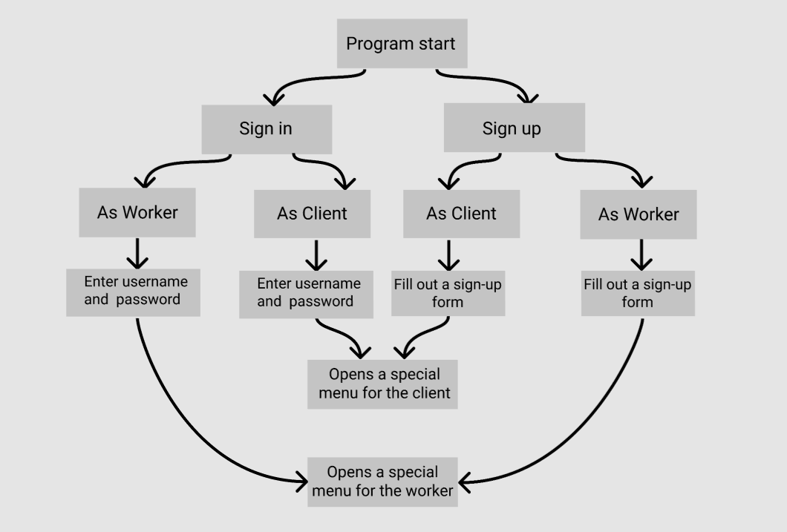

*Pic.1 Schematic representation of the program's work*

This is a simplified version of how our program works. First, there is the start of the program. If the user has already registered (as a bank employee or as a customer), he must enter his login and password. Then you will see a special menu of possibilities, depending on the type of account. If the user enters the program for the first time, then he should register. To do this, fill in the registration form. Depending on who the user wants to register on behalf, two different registration forms will be displayed. Further, after successful registration, it is necessary to enter your login and password. After that, a special menu of functions will be displayed, according to the account type. ( *Pic.1*)

Requirements for functional characteristics The Automated Information System "Educational Center" must ensure the performance of functions:

* Login to the account
* Ability to choose an option from the menu based on the type of person's account
* Possibility to search my client's name, last name
* Possibility to see the history of transactions, withdrawals, credit history, or credit potential
* Possibility to reject or approve the client
* The possibility to make automatic payments depends on the client's ability to pay
* Possibility to transfer money
* Convert currencies

# **Login**

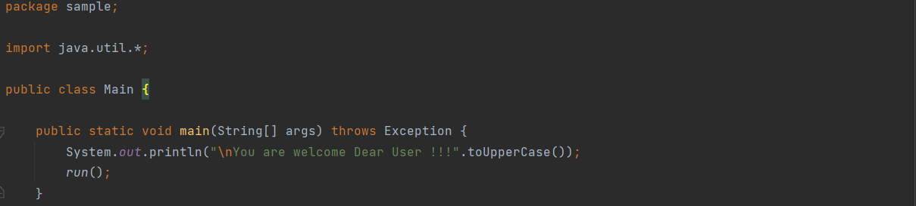

*Pic.2 Start before registration*

Logging in starts with the user greeting in the form of a message. (*Pic.2*)

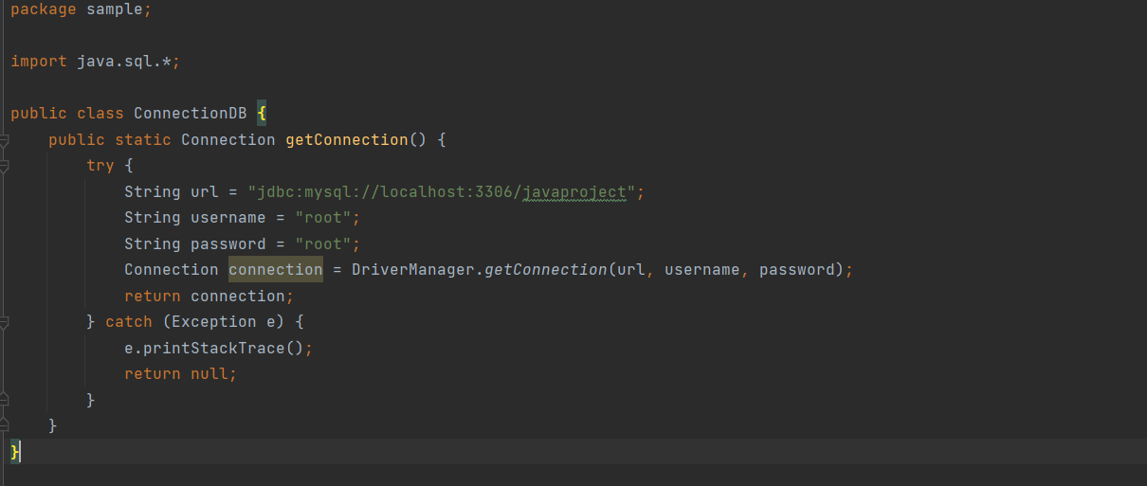

*Pic. 3 Code of connecting with database*

Connecting with jdbc Driver using User name, password from database, link from localhost. Displaying message about successful connection.

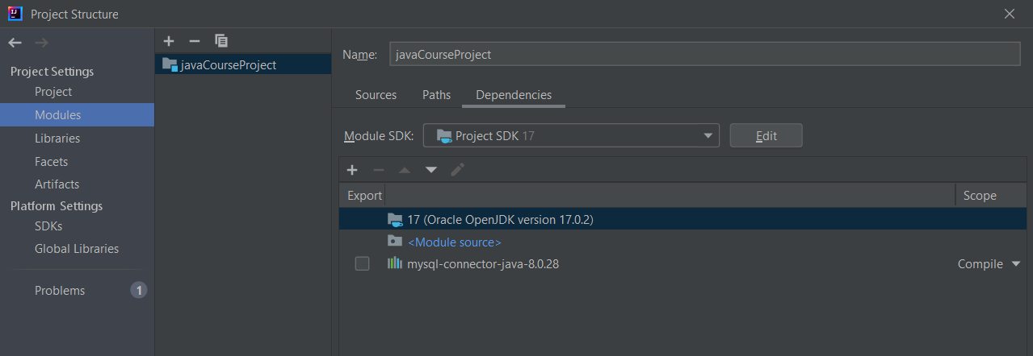

*Pic. 2 Connection with database using mysql-connector-java-8.0.28*

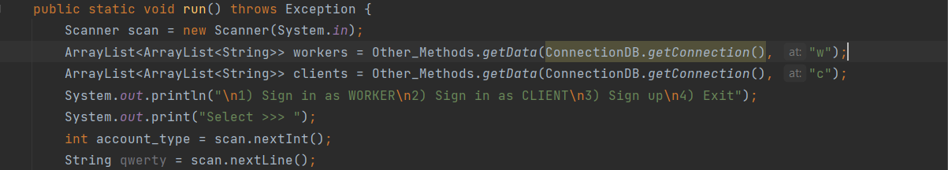

*Pic.3 Output of the main action menu*

Then the *run* method is run.

At the beginning of this method, the program displays the main menu consisting of 4 items (sign in as a worker, sign in as a client, sign up or exit), and asks the user to select the item number from the menu. *(Pic.3)*

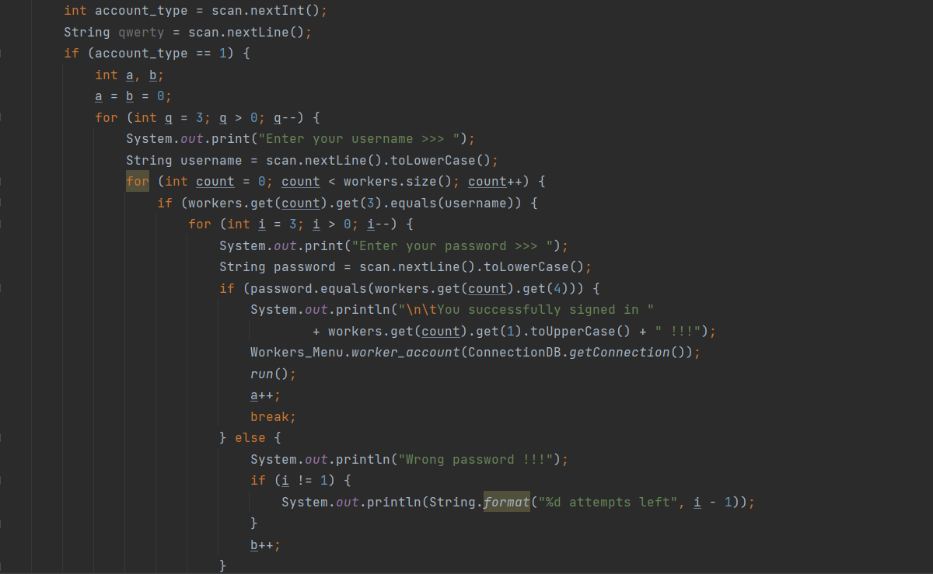

*Pic.4 Sign in as a worker*

The user-selected 1- sign in as a worker. The program asks for his password and logs in. He has 3 attempts to enter either his password or his login correctly. If the login and password are correct, the message about successful login will be displayed. Otherwise, the program will quit. *(Pic.4)*

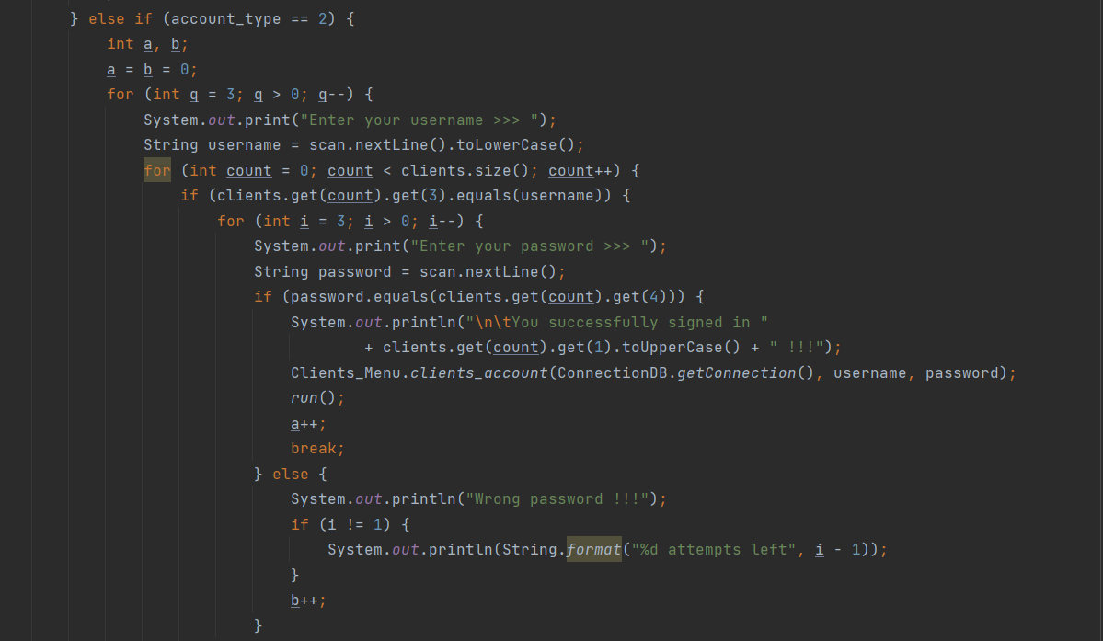

*Pic.5 Sign in as a client*

The user has selected 2 - sign in as a client. The program asks for his password and logs in. He also has 3 attempts to enter either the password or the login correctly. If the login and password are correct, the message about successful login will be displayed. Otherwise, the program will exit. *(Pic.5)*

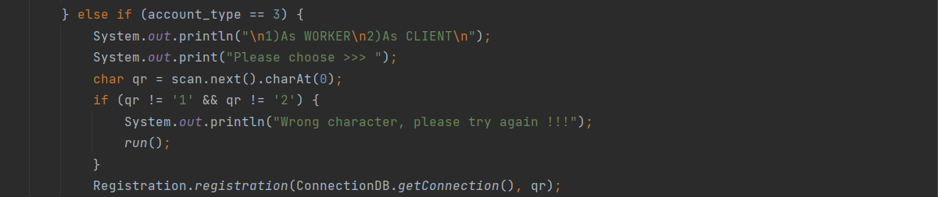

*Pic.6 Sign up*

The user has chosen to register. The program gives him the choice of registering as an employee or as a customer. You must enter the number 1 or 2. If you enter another character, the program will give an error and return you to the main menu*. (Pic.6)*

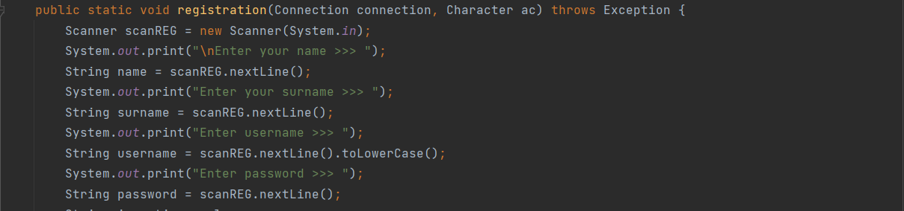

*Pic.7 Sign up form*

Regardless of who the user wants to register as an employee or as a customer, you must enter your name, last name, username, and password. *(Pic.7)*

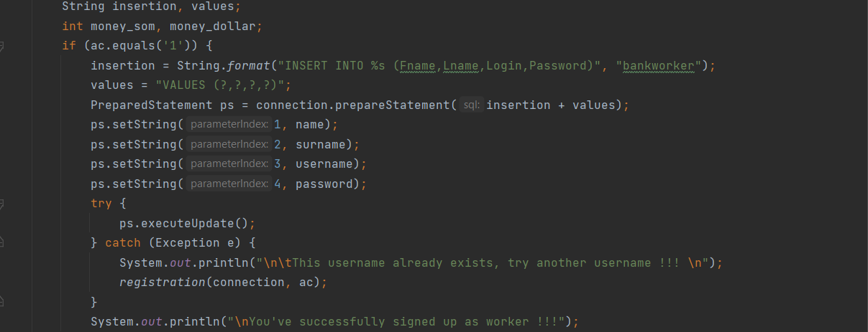

*Pic.8 Sign up form for a worker*

If the user wants to register as a worker, he must enter his first name, last name, username, and password. After that, there is a check. If there is already a similar username in the database, a different one should be entered. If the registration is correct, the new user is entered into the database and a message on successful registration is displayed. *(Pic.8)*

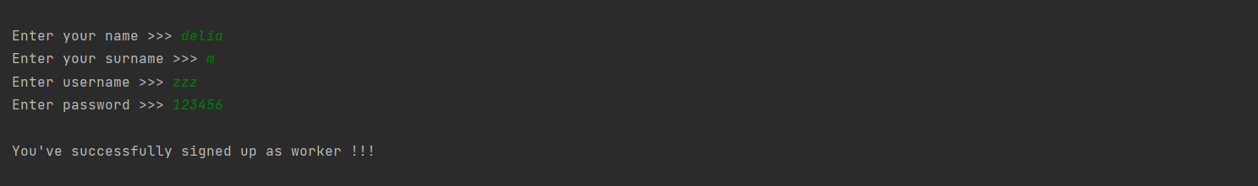

*Pic.9 Registration form for the worker*

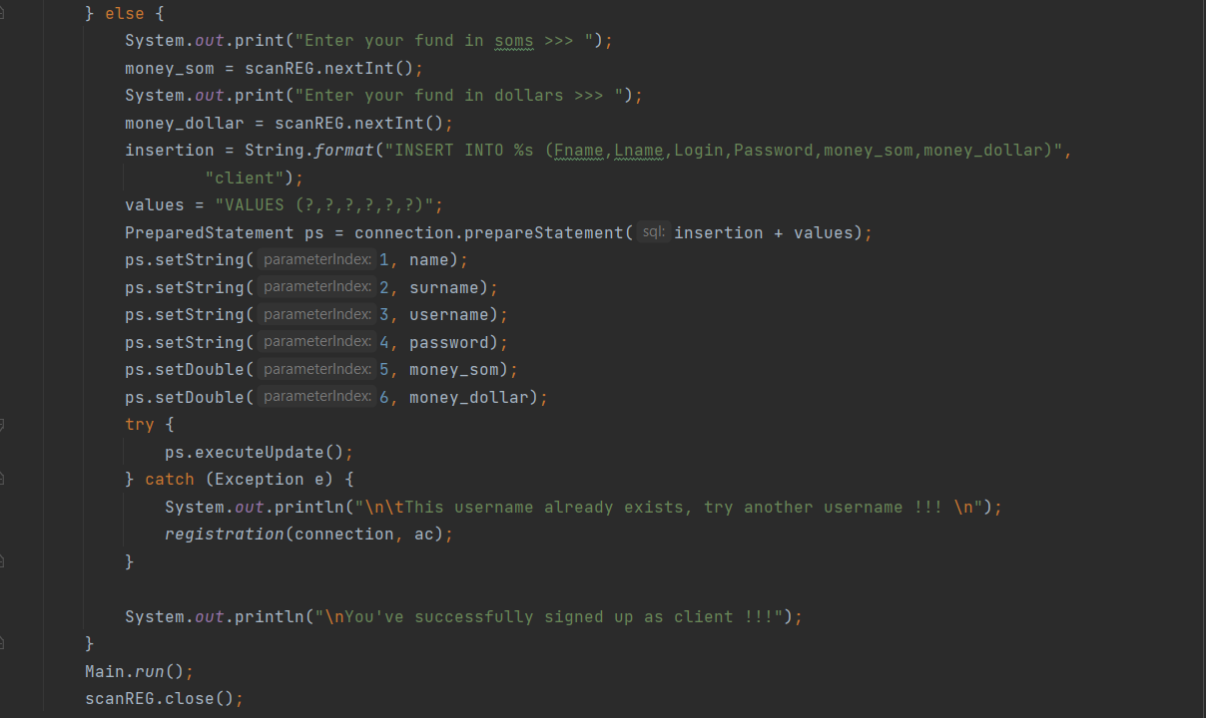

*Pic.10 Sign up form for a client*

If the user wants to register as a client, it will not be enough for him to enter his first name, last name, username and password. He will also have to enter the amount of money in soms and dollars. After that, there is a check. If there is already a similar username in the database, a different one should be entered. If the registration is correct, the new user is entered in the database and a message on successful registration is displayed. *(Pic.10)*

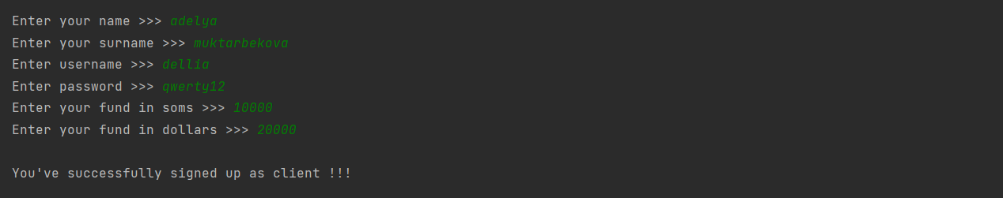

*Pic.11 Registration form for the client*

# **Account of worker**

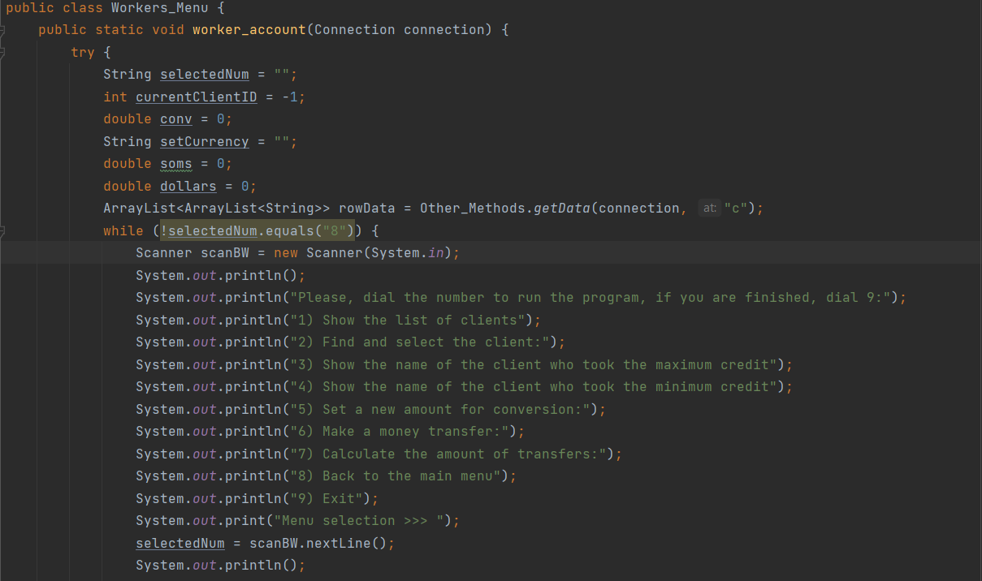

*Pic.12 Worker’s menu*

The worker's account begins by displaying a special menu for the worker with the names of the functions. *(Pic.12)*

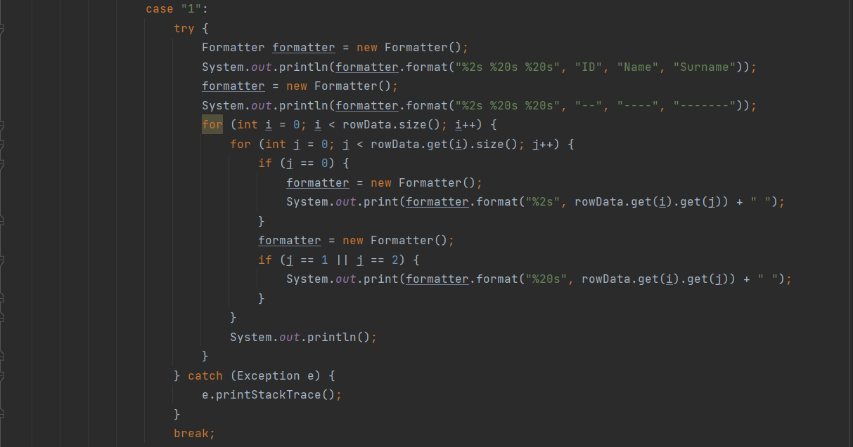

*Pic.13 The function to show a list of all clients*

If the user selects "1" from the menu, the worker is shown the entire list of clients that are in the database. *(Pic.13)*

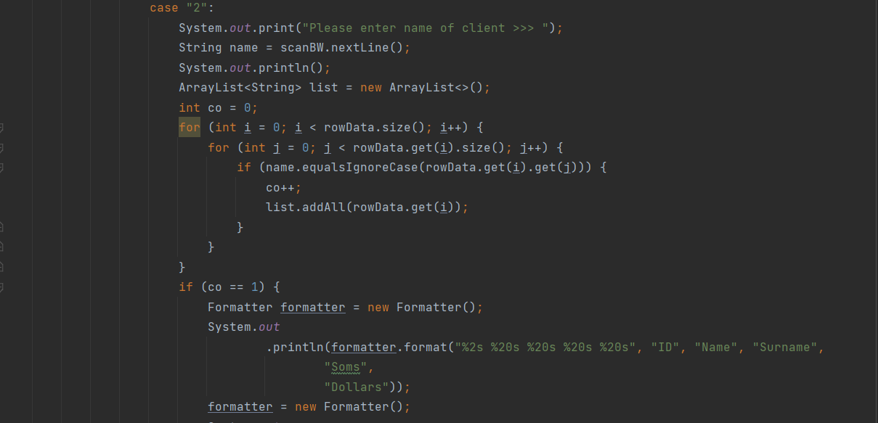

*Pic.14 Searching for a client*

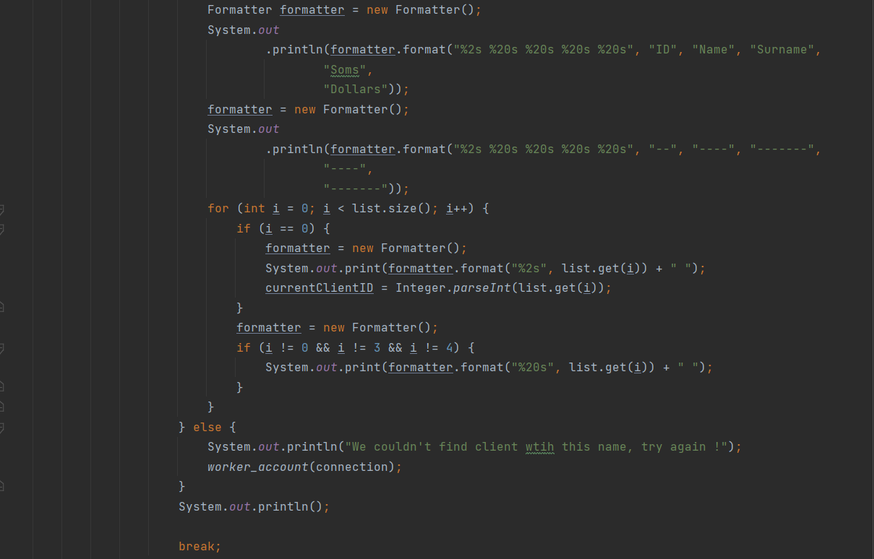

*Pic.15 Searching for a client*

When you click "2", the worker can find the client by entering the client's name. He will get full information about the client*. (Pic.14, Pic.15)*

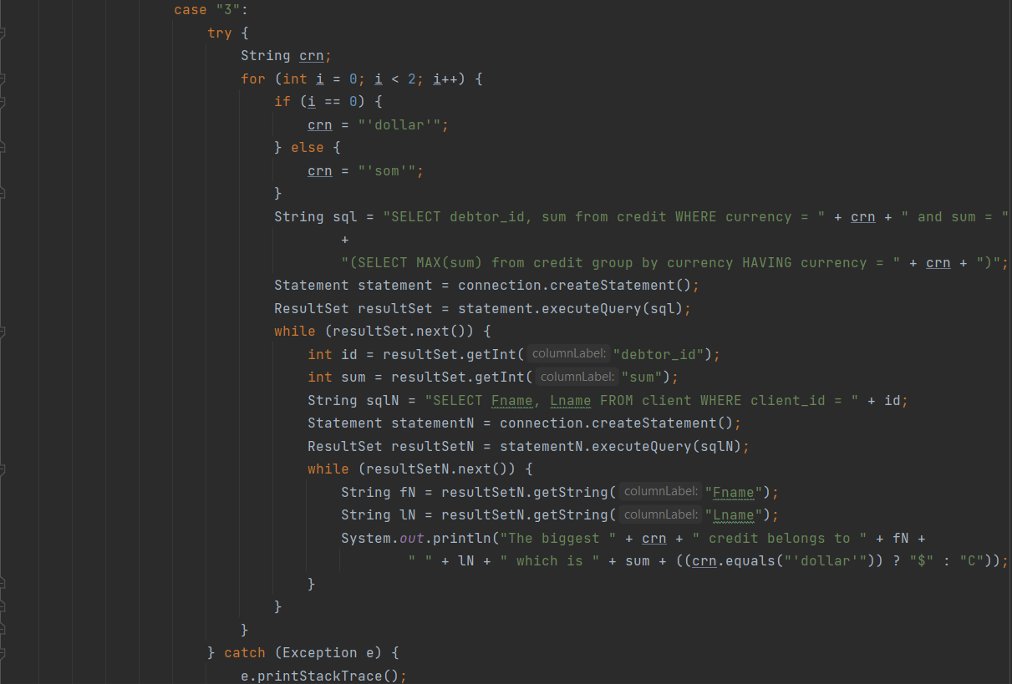

*Pic.16 Show the name of the client with the maximum credit*

This part of the method can show the bank employee the client who has the highest number of credits in soms and dollars. These values are stored in the database. *(Pic.16)*

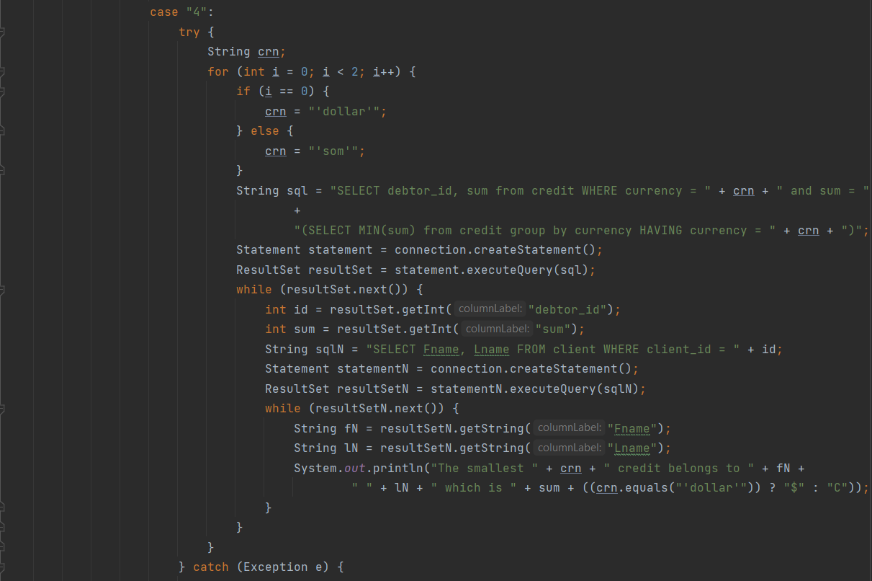

*Pic.17 Show the name of the client who took the minimum amount of credit*

When you click the item "4" from the menu, the employee displays the client’s name who took the minimum amount of the client. This is also stored in the database and is displayed automatically. *(Pic.17)*

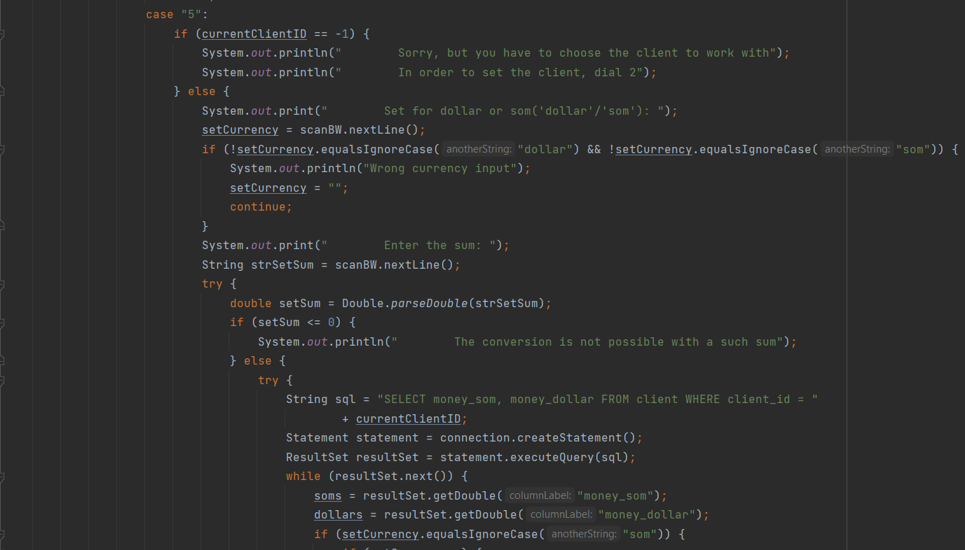

*Pic.18 Set a new amount for conversion (in dollars and soms)*

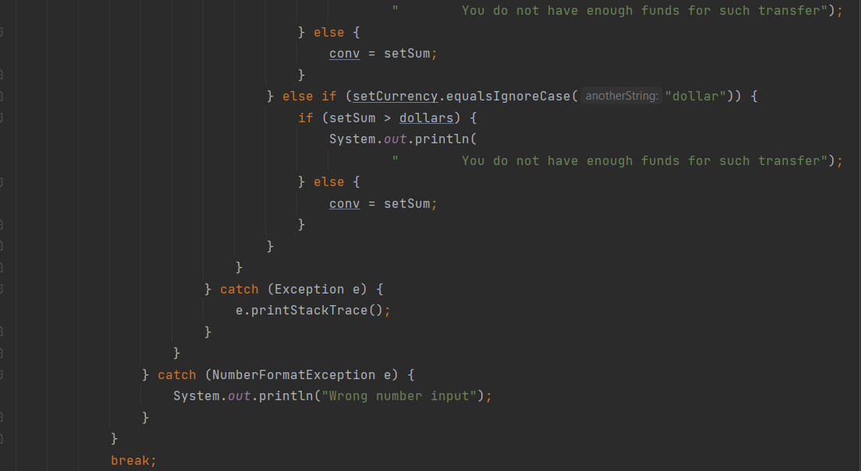

*Pic.19 Set a new amount for conversion (in dollars and soms)*

By pressing the item "5" from the menu we can enter the amount for the new conversion. *(Pic.18, Pic.19)*

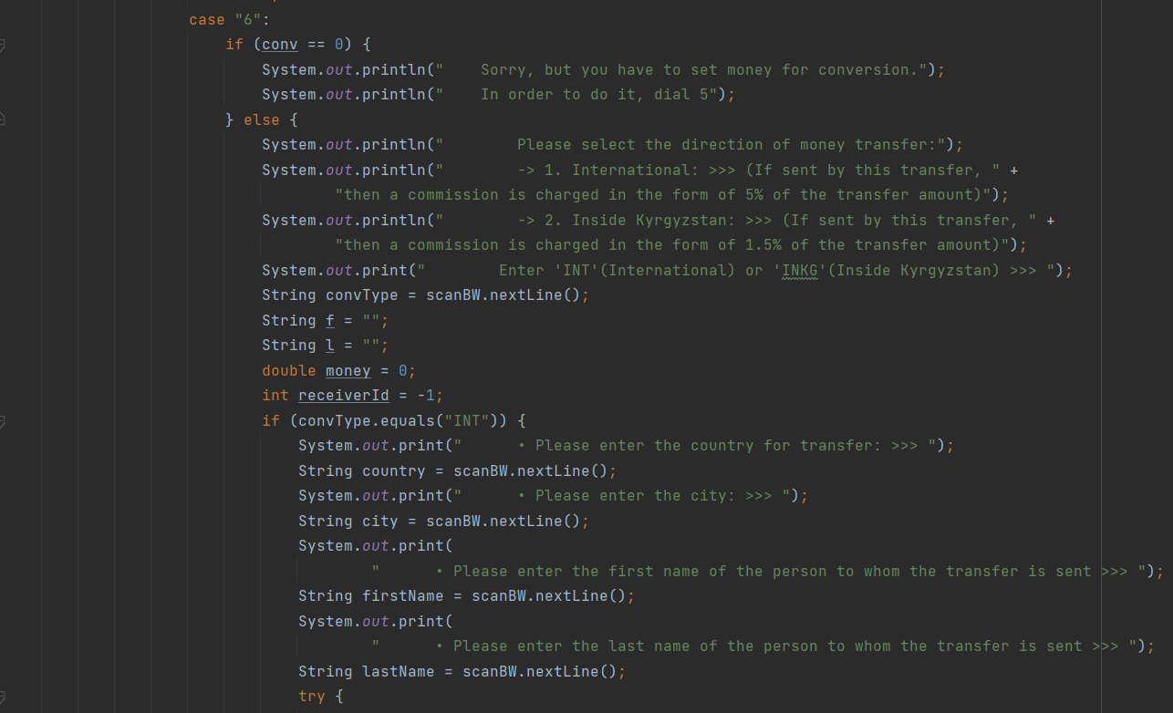

*Pic.20 Make a money transfer*

There is an International transfer (If sent by this transfer, a commission of 5% of the transfer amount is charged). You need to enter the country, city and full name of the person you are sending the transfer to. Also the code for to get money. *(Pic.20)*

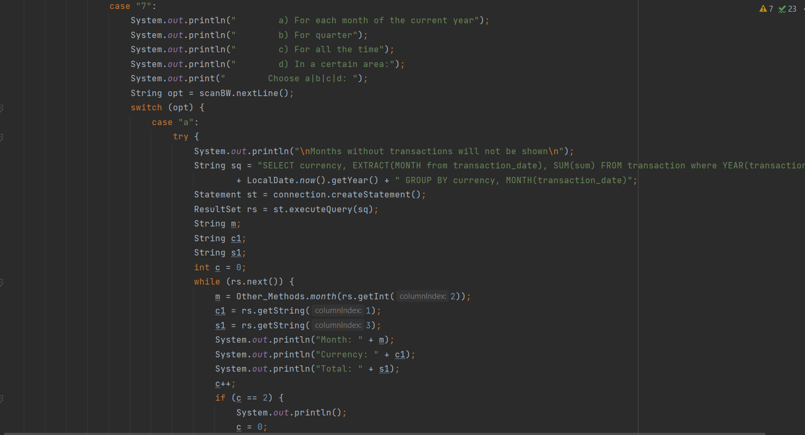There is also a transfer inside Kyrgyzstan (if you send by this transfer a commission of 1.5% of the transfer amount is charged). You have to enter the city and the full name of the transfer recipient. The code for receiving money is also displayed. *(Pic.20)*

*Pic. 21 Calculate the amount of transfers*

When you press item "7", the bank employee can calculate the amount of transfers for the year, quarter, for all time and for a certain period of time. (*Pic.21*)

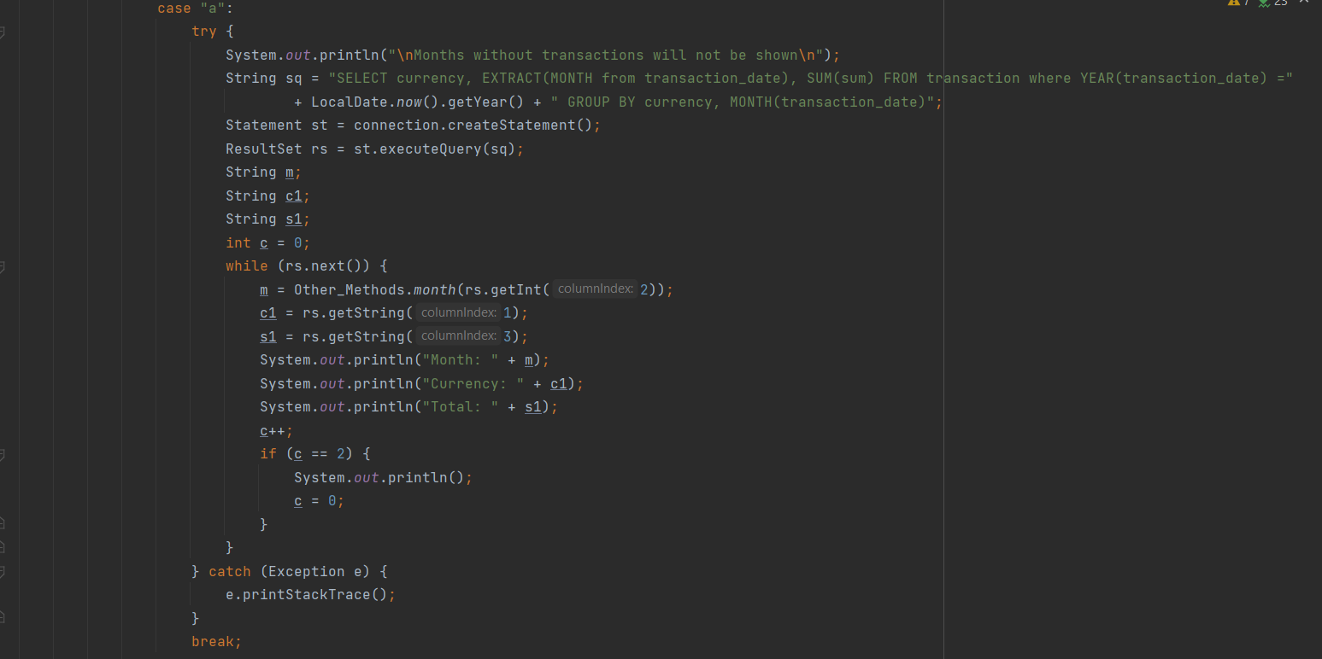

*Pic. 22 Calculate the amount of transfers for each month of the current year*

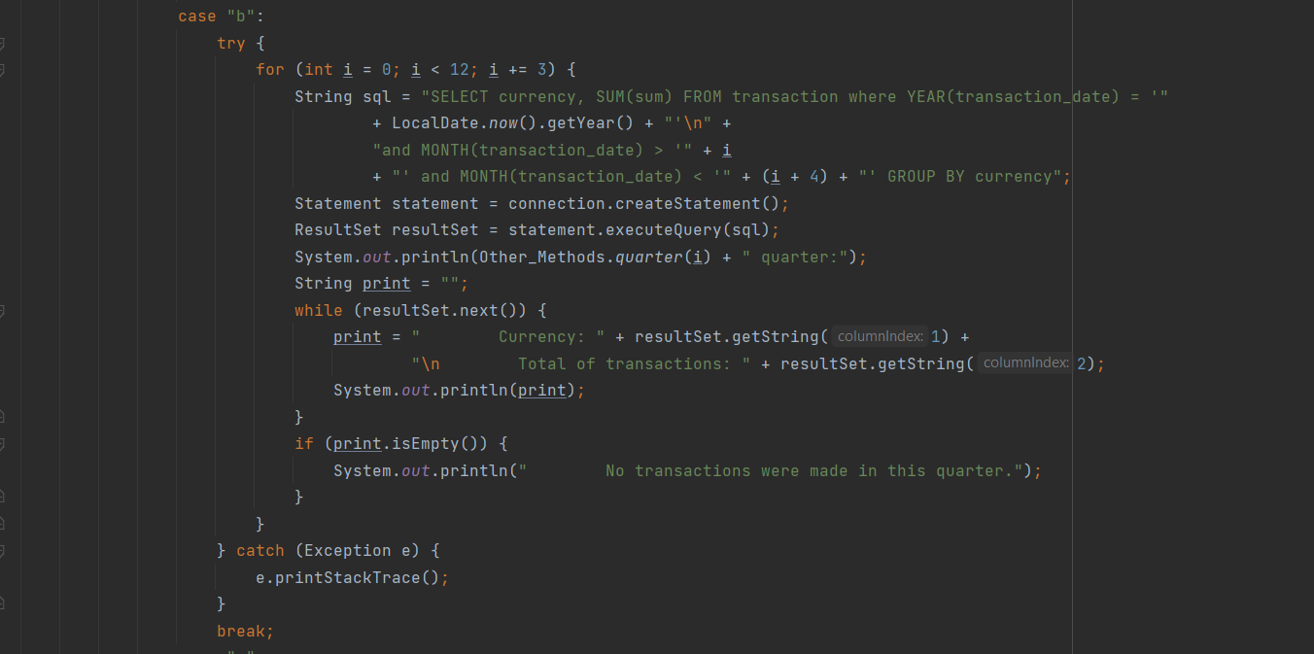

*Pic. 23 Calculate the amount of transfers per quarter*

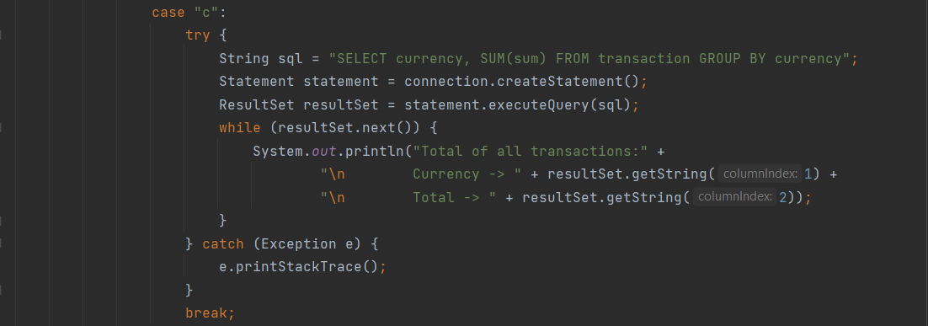

*Pic. 24 Calculate the amount of transfers for all time*

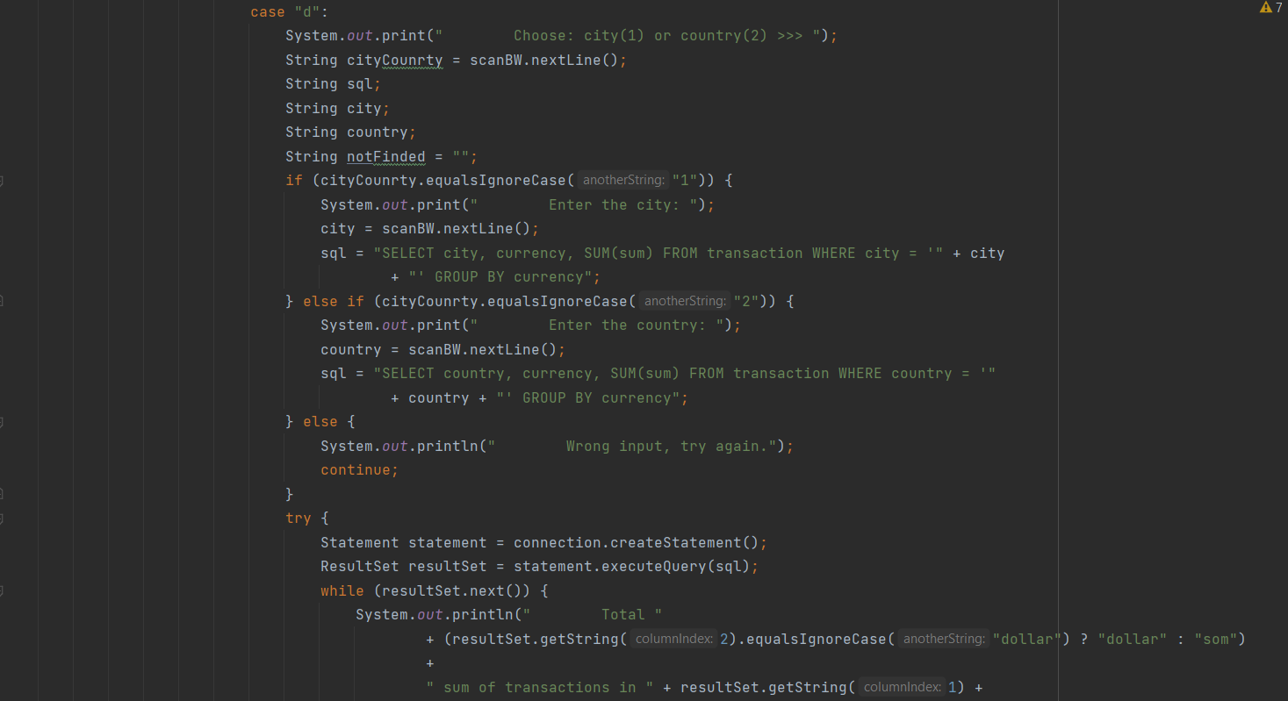

*Pic. 26 Calculate the amount of transfers for a specific area*

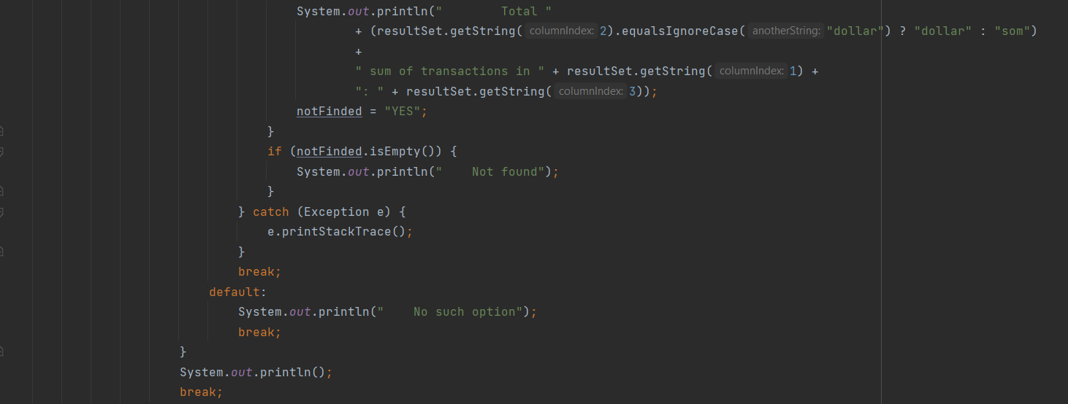

*Pic. 27 Calculate the amount of transfers for a specific area*

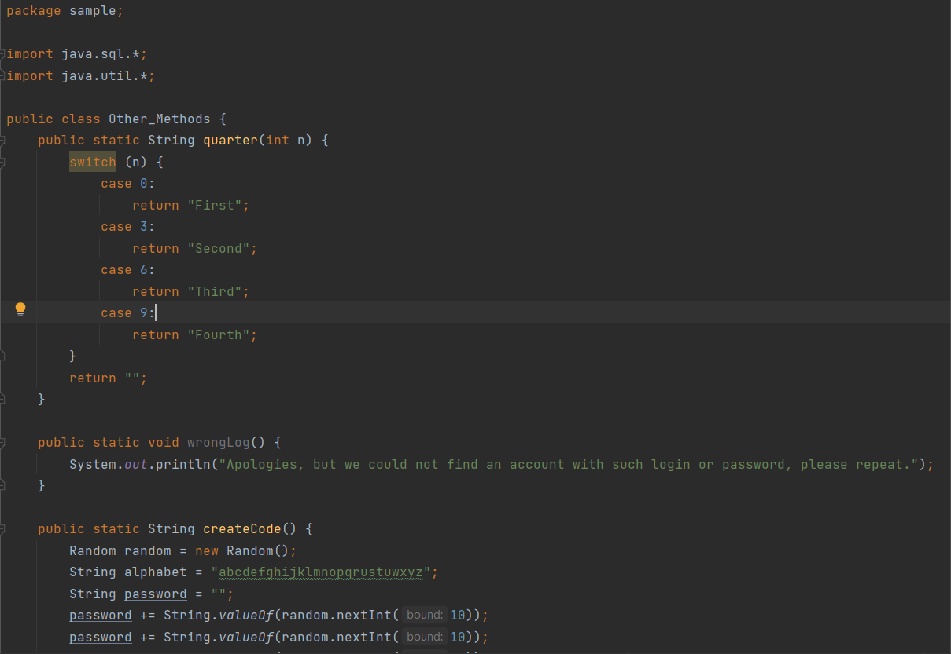

Pic

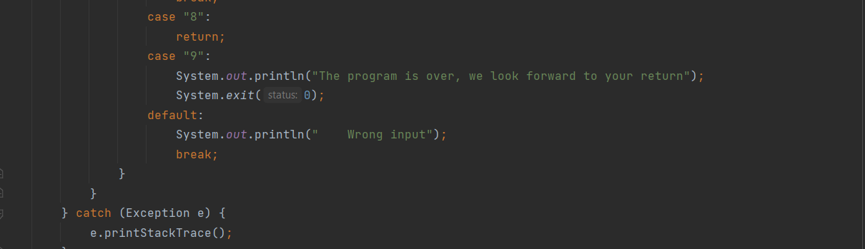

*Pic. 28 Return to the main menu or exit the program*

If the user wants to return to the main menu, he should press "8". And if he wants to end the program, he should press "9". *(Pic.28)*

# **Account of client**

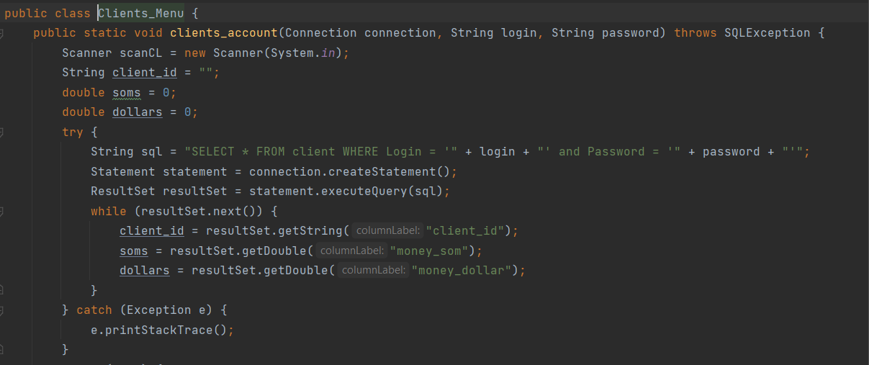

*Pic.29 Menu of client*

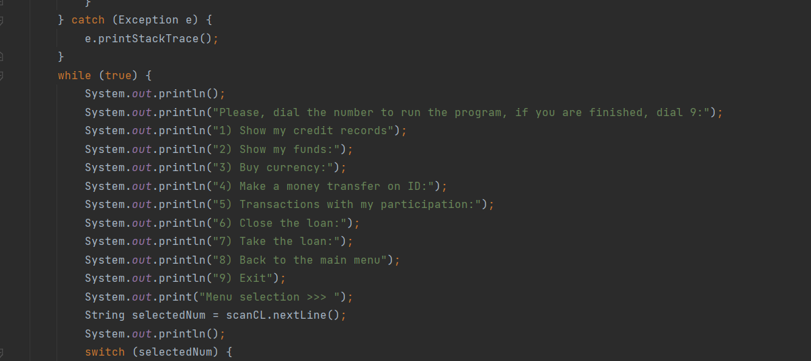

*Pic.30 Menu of client*

If the user correctly entered his login and password from the client account, then he opens its special features menu. *(Pic.29, Pic.30)*

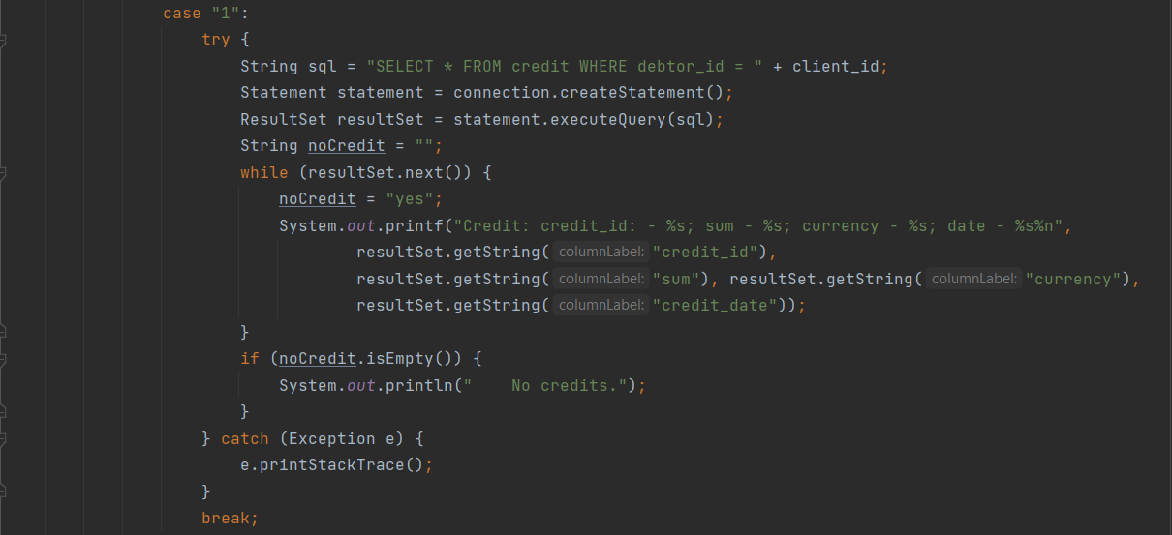

*Pic. 31 Show my credit list*

When you click "1" from the client menu, the user can see the amount of their credit. *(Pic.31)*

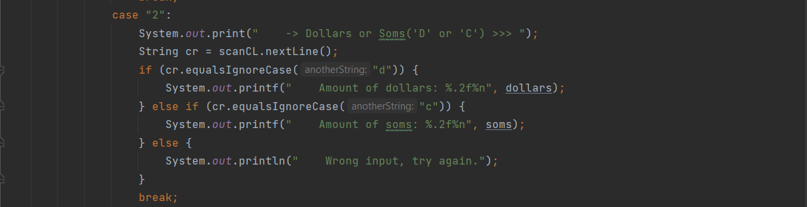

*Pic. 32 Show funds*

The function number 2 shows how many dollars and soms the client has in his account. *(Pic.32)*

**

*Pic. 33 Result of 2 function in dollars*

**

*Pic. 34 Result of 2 function in soms*

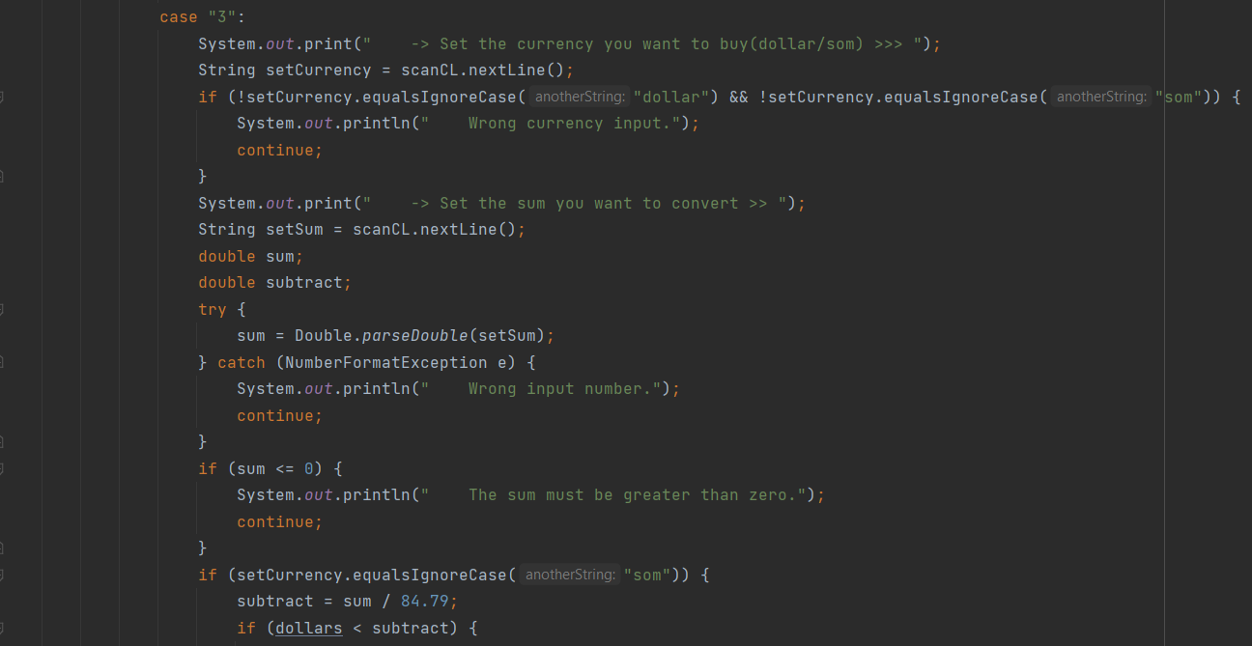

*Pic. 35 Buy currency*

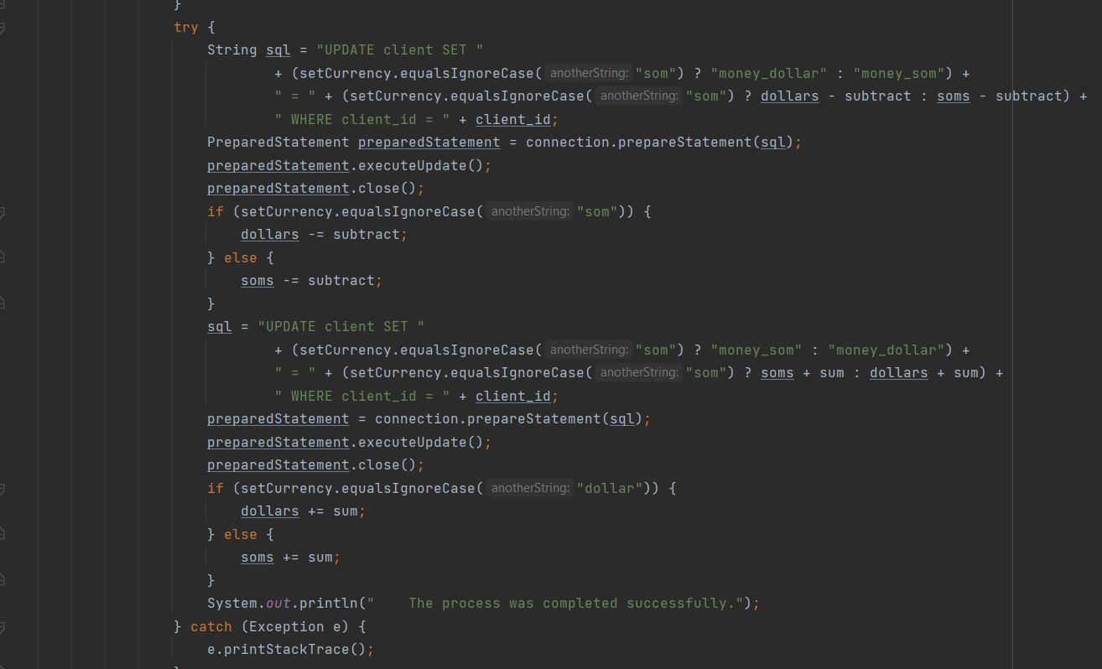

*Pic. 36 Buy currency*

The customer specifies the currency he would like to buy and the amount. (*Pic. 35, Pic. 36)*

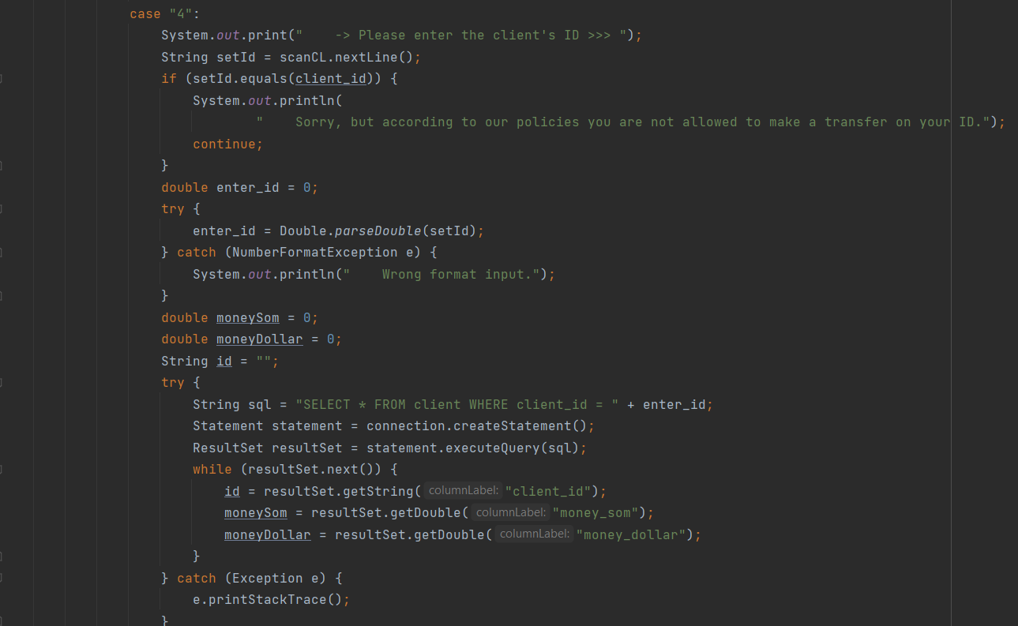

*Pic. 37 Make a money transfer based on customer ID*

In function number 4, the client can transfer a certain amount of money to another person (also a client). (*Pic.37)*

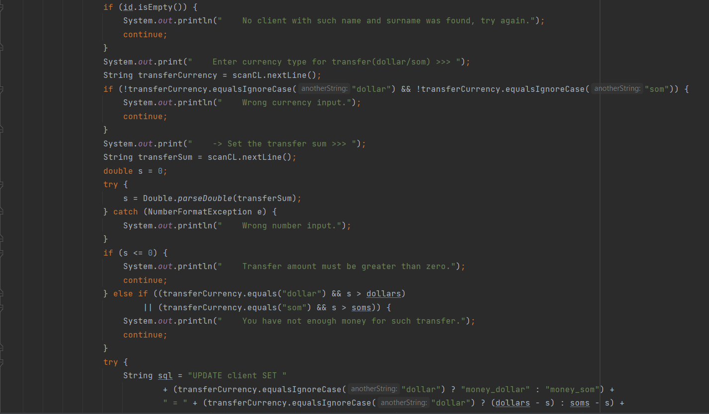

*Pic. 38 Make a money transfer based on customer ID*

The program will give him a choice in which currency he wants to make the transfer. *(Pic.38)*

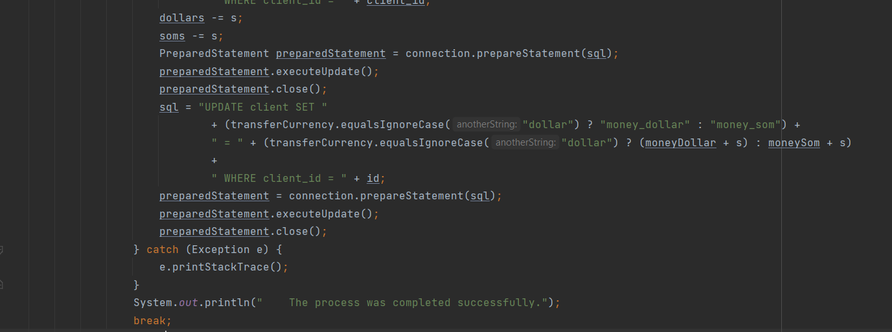

*Pic. 39 Make a money transfer based on customer ID*

To do this, he must know the person's ID in advance and specify this number when transferring the money. At the end of the process, if all the actions have been performed correctly, the money will be transferred and in the updated table in the database you can see the changes. *(Pic.39)*

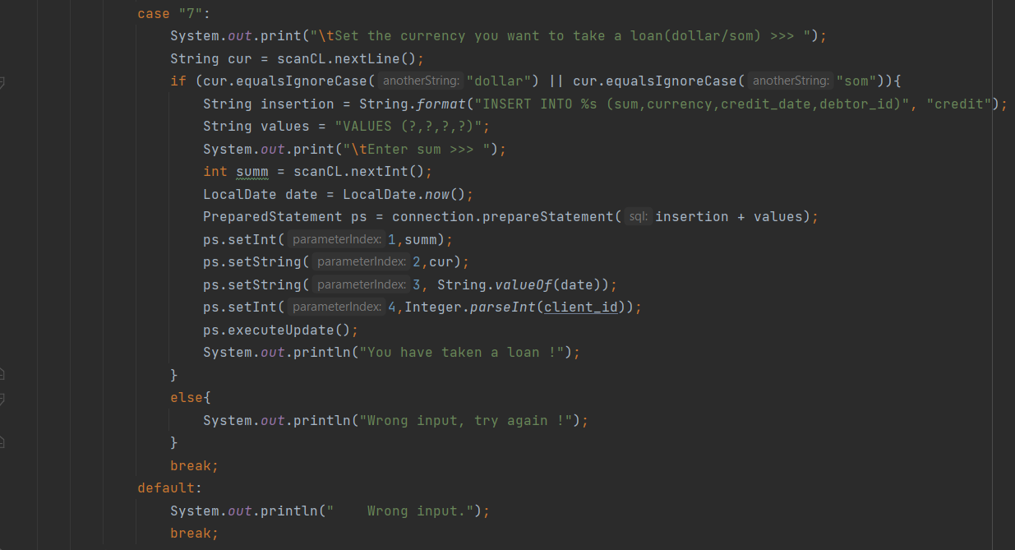

*Pic. Credit is taken on behalf of the client*



*Pic. 40 Finish or to the main menu*

If the client wants to go back to the main menu, he presses 8, and if he wants to end the program, then 9*. (Pic.40)*

# **Conclusion**

The work on the coursework project was done equally by each team member. Thanks to this we learned a lot about using the Java programming language and the MySQL Connector database.

The official system for both designing and administering MySQL databases. We chose this database because of its user-friendly graphical interface, which allows you to easily create a database structure of any complexity, and visibility will allow you to easily navigate. A few more advantages of MySQL Workbench:

* Visibility
* Easy editing
* Development does not require a connection to a server

It simplifies many aspects of working with the database: creating tables and links between them, creating triggers and procedures, visual representation of the schema, setting up the database and creating backups.

We fully relied on the terms of reference, but improvisation was also an integral part of writing the project. Our team achieved our goal, namely the development of a banking system for easy use by both customers and bank employees.

Over the course of the project, there were many tasks that we accomplished:

* Creation of accounts for bank customers and employees
* Registration Authorization
* Money transfer
* Cash balance display
* Searching for customers
* Show the amount of all transfers
* Database connection

# **What we learned?**

Working on the coursework was very difficult but at the same time very exciting work. During the research of the topic of our term paper, our team got to know each other better. We also gained skills such as:

* + - Communication skills.

The ability to communicate effectively is the basis for success in teamwork. All team members must be able to express themselves clearly and concisely, whether they are communicating in person, by phone, or by email.

* + - Listening Skills.

Effective communication is impossible without the ability to not only listen but also to hear.

* + - A responsible attitude to the tasks at hand.

Teamwork implies that a group of people work together to achieve a common goal. It is important for productive work that team members be able to rely on each other.

* + - Knowing how to handle conflict situations.

Avoiding conflict in the workplace is almost impossible. Disagreements happen from time to time in any team. And the ability to cope with conflict situations is an essential skill for any specialist. You must learn to keep your own emotions under control and find solutions that suit all team members.

* + - Tolerance.
    - Problem-solving and the art of asking questions.
    - Understanding why code works (or not)
    - Working with strings
    - Working with lists
    - Using loops
    - Using functions (and proper terminology)

# **References**

We would like to share the sources from which we got the information we needed. The material was taken from websites:

* <https://www.youtube.com/>
* <https://www.google.ru/>
* <https://stackoverflow.com/>
* <https://github.com/>
* <https://dev.mysql.com/doc/workbench/en/wb-intro.html>
* https://en.wikipedia.org/wiki/Java_ (programming_language)
* https://dev.mysql.com/doc/workbench/en/wb-mysql-connections-new.html

Some chat rooms for programmers on the social network Telegram were also visited.